COMPUTER NETWORKS QUIZ-03 (B) SOLUTION – BCS-5G

  - First segment: seq= 494 , bytes= 499
second segment: seq= 993, bytes=499
third segment: seq= 1492, bytes 499
  - ACK for 2nd segment: 993
ACK for 3rd segment: 993
  - UDP segment structure 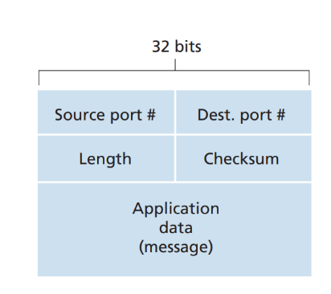
  - Size of UDP datagram:
UDP Header + application layer header + message data
= 8 bytes + 700 bytes + 8 bytes
= 716 bytes

  - Sample 1:
EstimatedRTT = (1-0.125)(200) + (0.125)(200) = 202.5
DevRTT = (1-0.25)(20) + 0.25(|220-200|) = 20
TimeoutInterval = 202.5 + 4(20) = 282.5
  - Sample 2:
EstimatedRTT = (1-0.125)(202.5) + (0.125)(210) = 203.44
DevRTT = (1-0.25)(20) + (0.25)(|210-202.5|) = 16.875
TimeoutInterval = 203.44 + 4(16.875) = 270.94
  - Sample 3:
EstimatedRTT = (1-0.125)(203.44) + (0.125)(240) = 208.01
DevRTT = (1-0.25)(16.875) + (0.25)(|240-203.44|) = 21.796
TimeoutInterval = 208.01 + 4(21.796) = 295.194

  - Issue with Two-Way Handshake:
Old or Delayed Packets: In a two-way handshake, there is no verification if the connection request is new or an outdated packet. A delayed packet could unintentionally trigger a connection, causing confusion.
Synchronization Problem: The two-way handshake does not confirm if both the client and server have successfully synchronized their sequence numbers, leading to possible data misalignment.
  - Solution with Three-Way Handshake
1. SYN (Synchronize): The client sends a connection request (SYN) to the server with an initial sequence number.
2. SYN-ACK (Acknowledge + Synchronize): The server responds with a SYN-ACK, acknowledging the client’s SYN and sending its own initial sequence number.
3. ACK (Acknowledge): The client sends an ACK back to the server, confirming the server’s sequence number.
This three-step process ensures:
Reliability: Both the client and server confirm the connection request, reducing the risk of old or duplicate connection attempts.
Synchronization: Both the client and server synchronize their sequence numbers, ensuring data is properly aligned for transmission.

